SW PROJECT > WEEK 3: Web Application Design

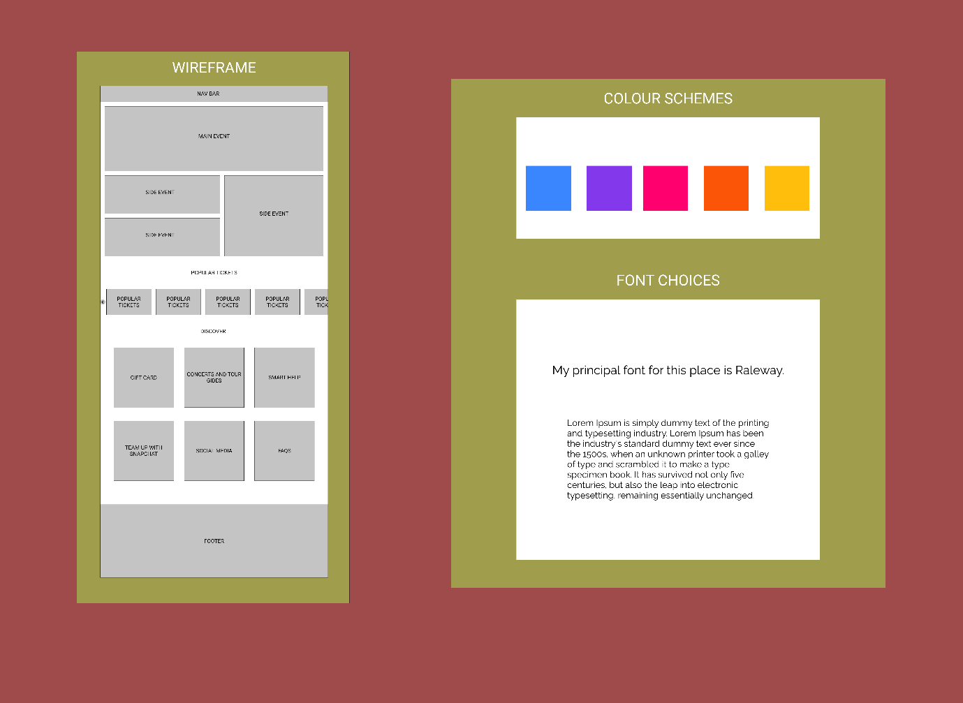
Layout of my ticket selling webpage, wireframe, colour scheme and font choice.

